Development Diary

Table of Contents
Development Diary 1
Version 1.0; 1
Version 1.1; 4
Version 1.2; 5
Version 1.2; 7
Version 1.3; 8
Version 1.4; 9
Version 1.5; 9

Version 1.0;
I have created the solution for my project. I have appended my models, added Google authentication and started seeding data. I have also scaffolded my views with EF.
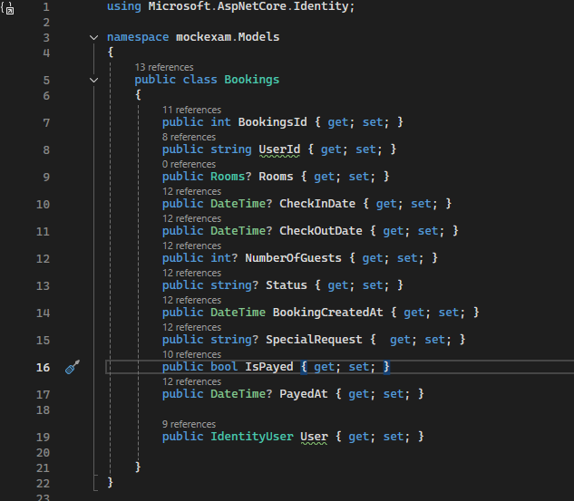
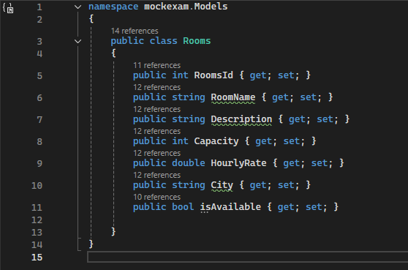
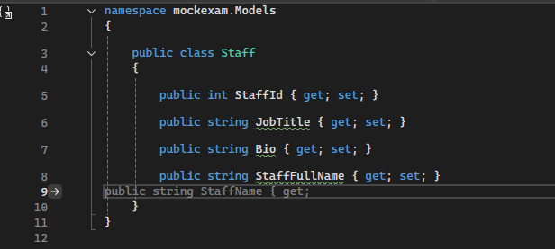
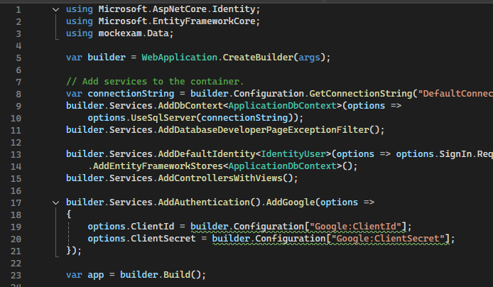
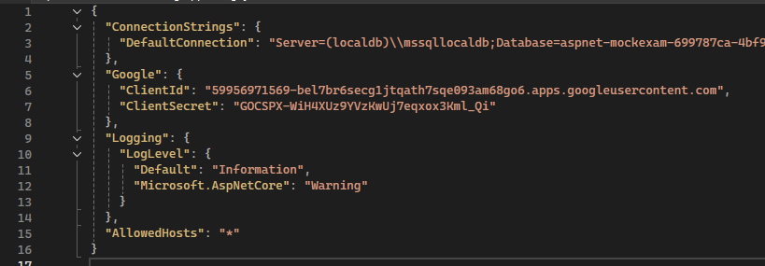
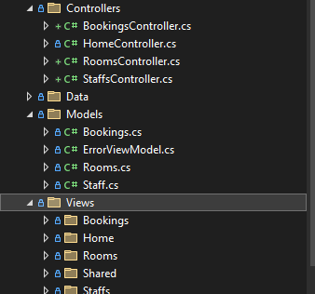

Version 1.1;
I have added seeding to my solution, providing pre generated rooms when ran, as well as an admin account.
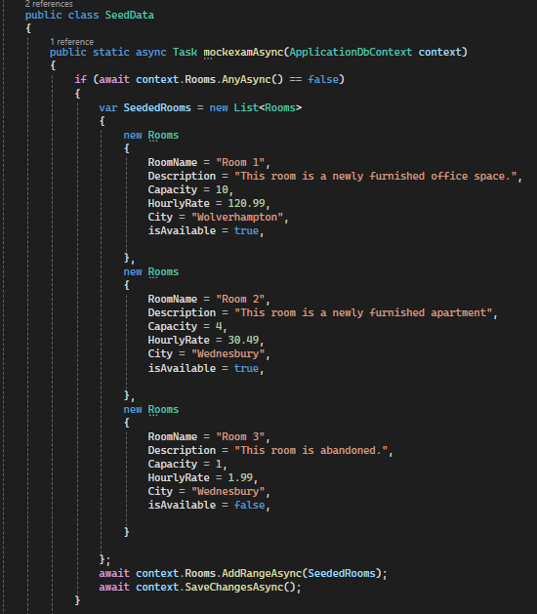

Version 1.2;
I have added all user roles required and ensured they have worked.

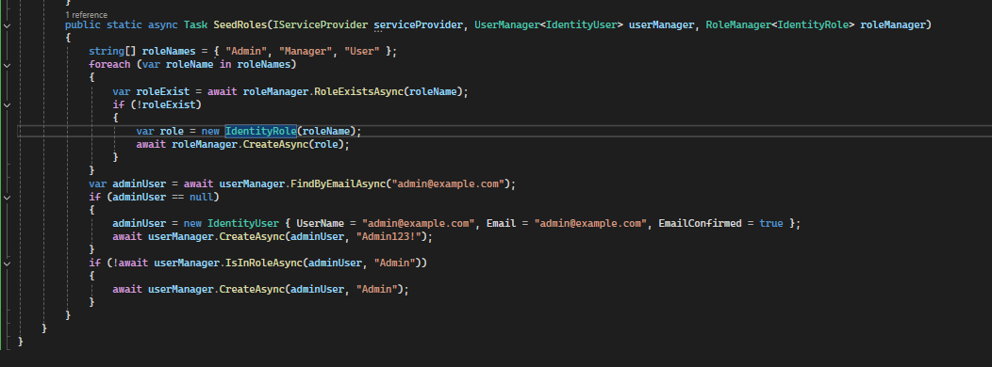

Version 1.2;
I have added all user roles required and ensured they have worked. 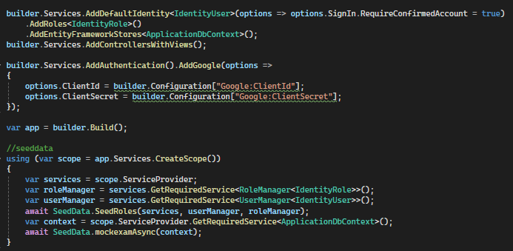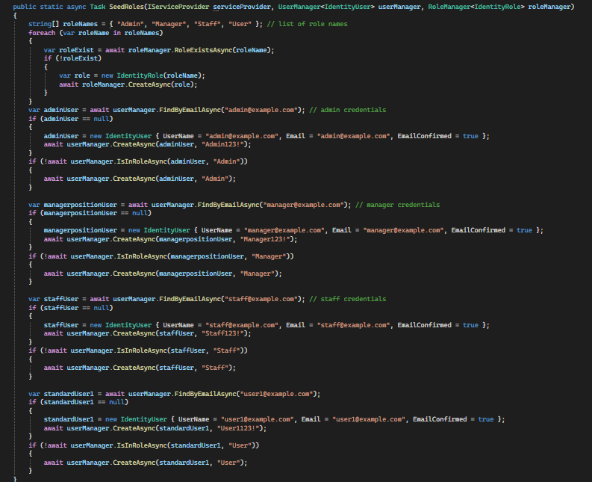

Version 1.3;
I have realised that I made my models wrong, so I have edited my Rooms model to fix this. I did this by adding an ICollection into bookings.
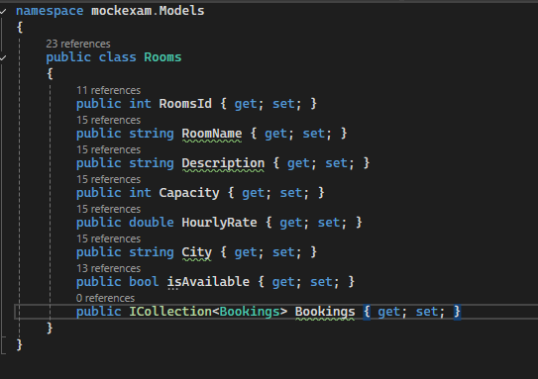
I have added User Role Restrictions to certain pages to ensure that only select people can access certain webpages.
Rooms:
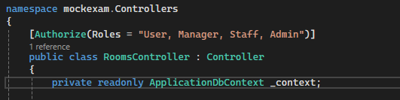
Bookings:
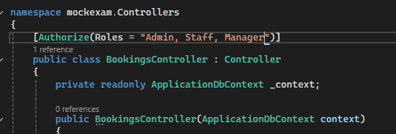
Staff:
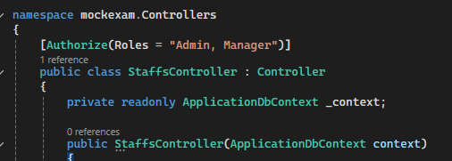

Version 1.4;
To ensure users understand why they’ve been restricted, I have edited the Access Denied Page to be clearer.
I have also made some amendments to the front-page asking users to sign in or register with the website.

Version 1.5;
I have tried to make it so users see different layouts depending on their user roles, however I have not been able to achieve this yet. I intended to do this by having 2 layouts, one for authenticated users and one for non-signed in users. I would then use the _ViewStart page to maintain the swap.
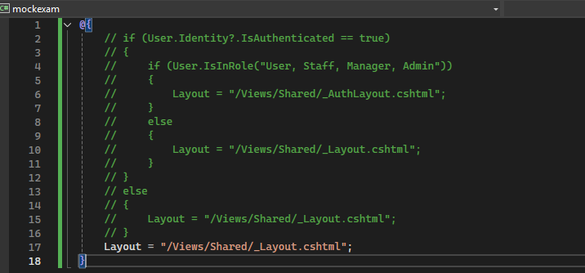
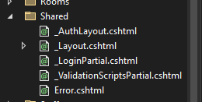

Version 1.6;
I have made some adjustments to how the model functions, after getting errors when it came to the model state. I have removed the requirement for the IdentityUser parameter to be filled.
